4. SYSTEM DESIGN

- The first thing you see when you open the application. The Home page.

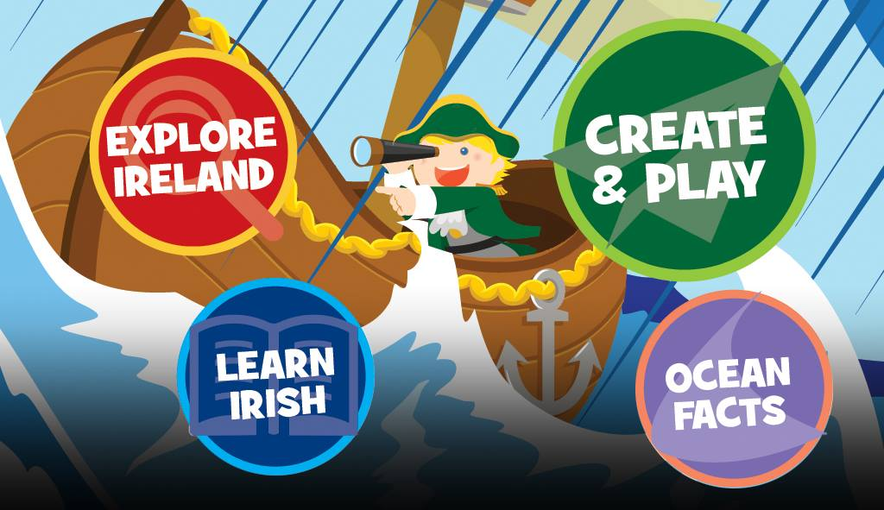

-Designed well, shows all the different sections of the application.

-Attractive to the eye. Captures children’s attention.

4.1 Create and play

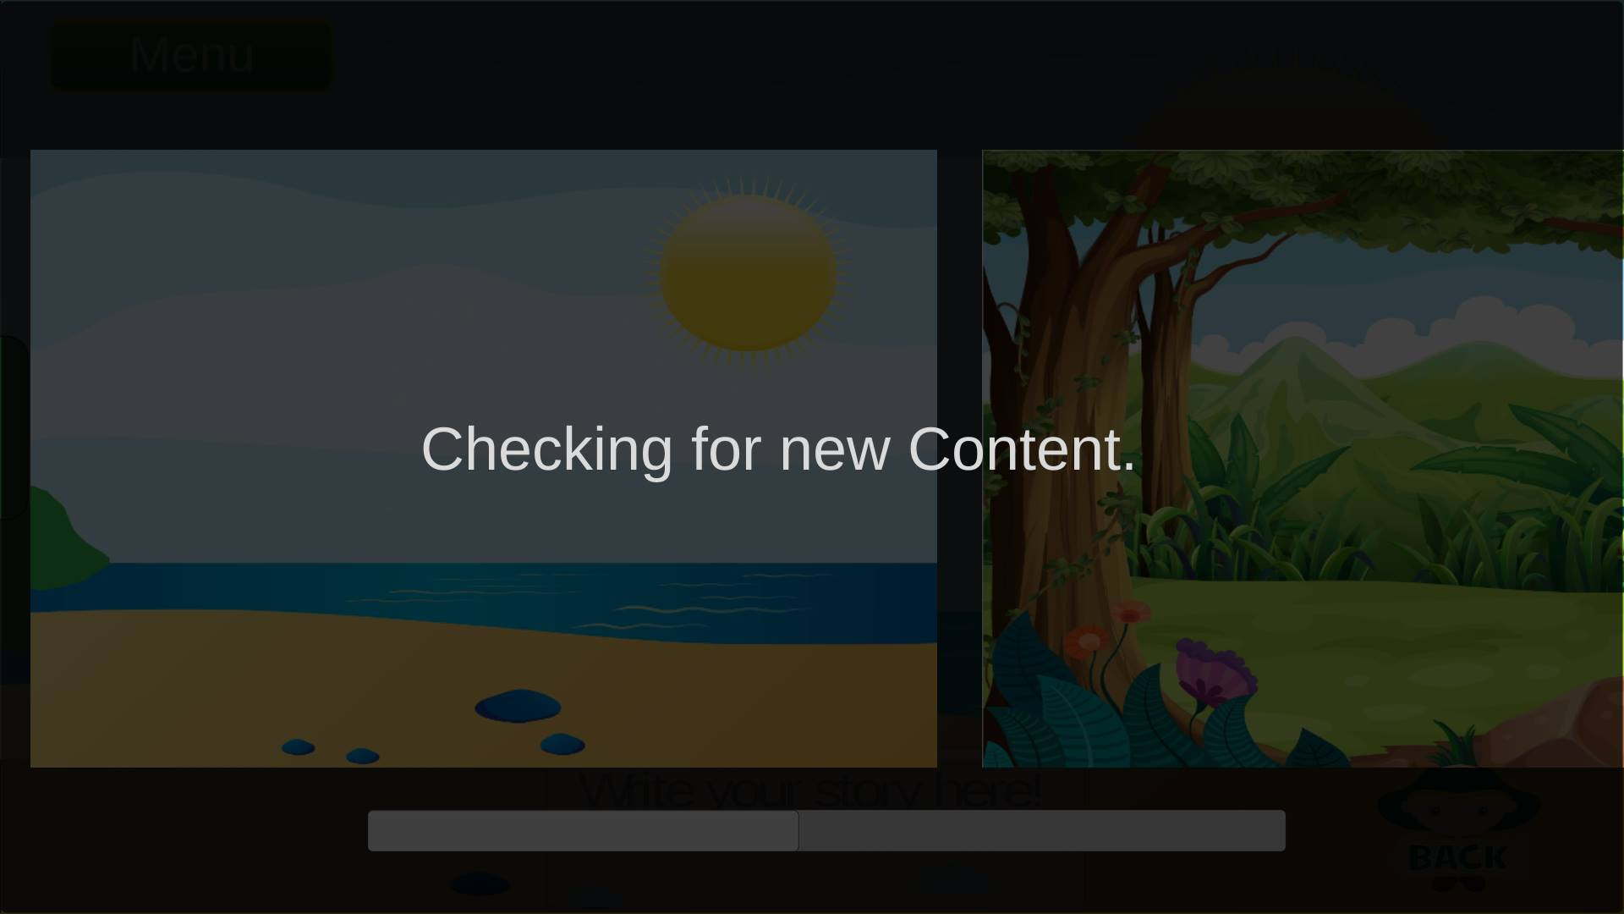

-This is in the Create and play section.

- This screenshot shows that the game is connecting to the database we have running in the background.

-It checks if new input was added.

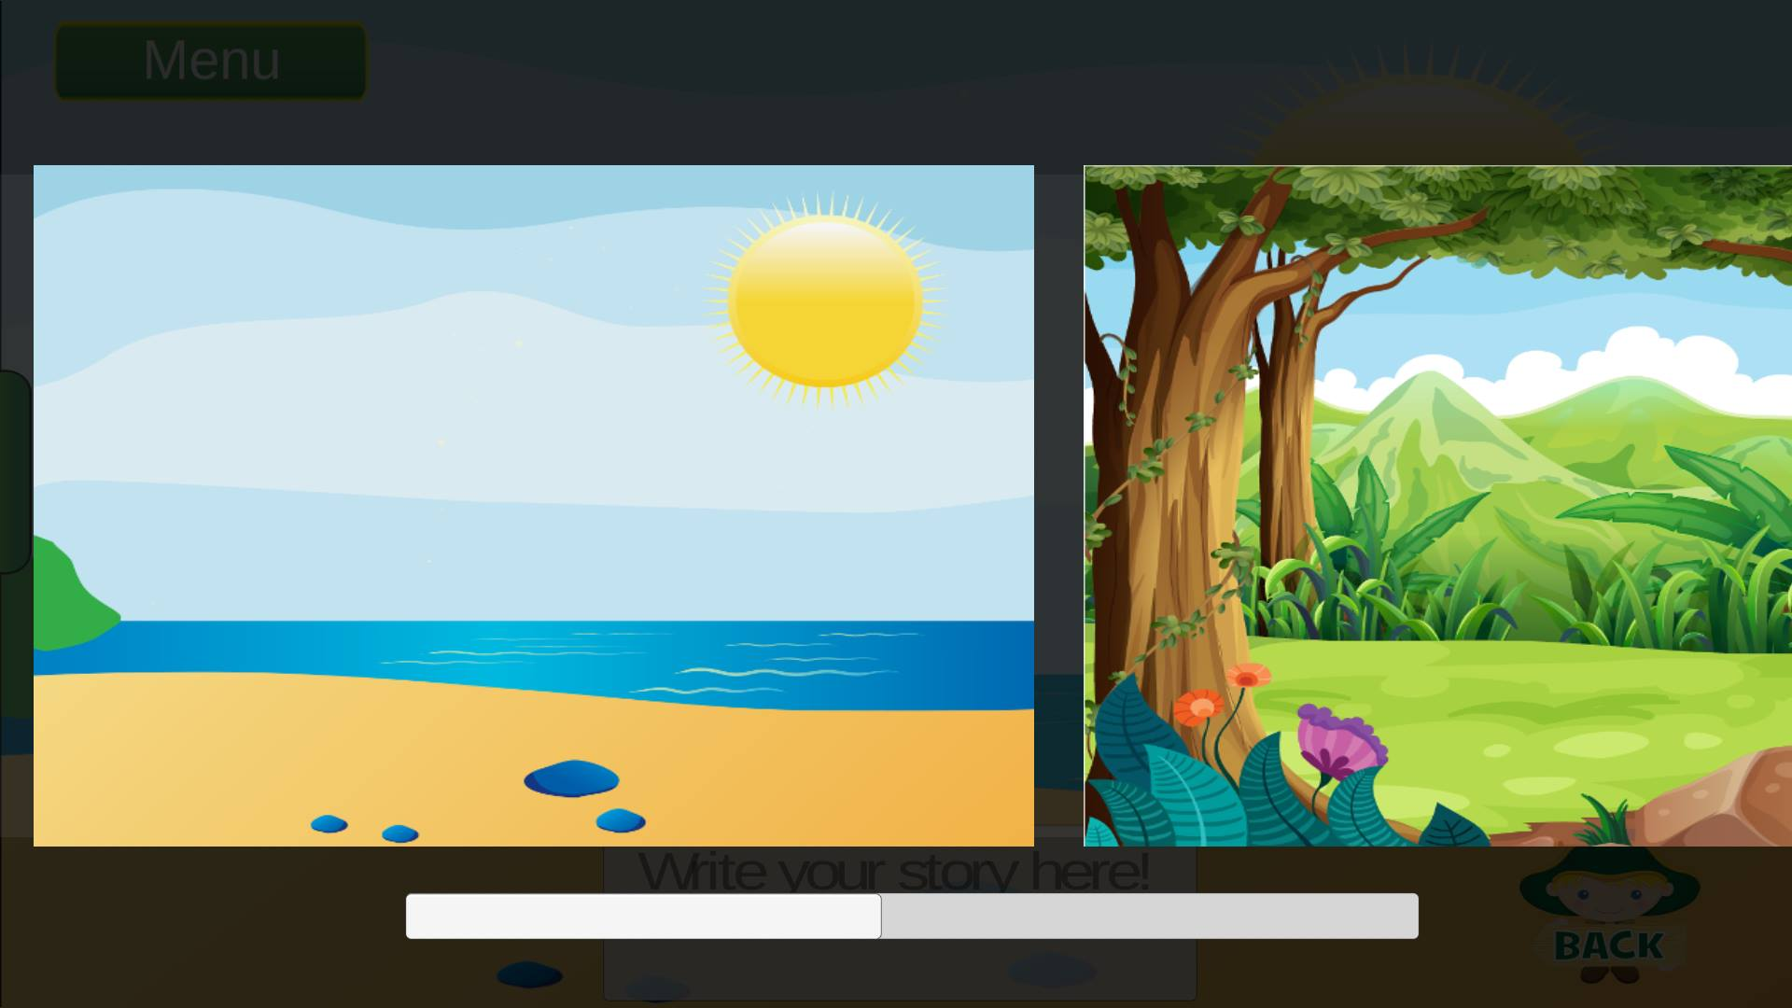

-In this screenshot you can see a few images.

-These are the scenes you can choose to create your story.

-We are using many new features that we haven’t used before.

-This screenshot shows the game in action.

-As you can see a few of the icons were added to the scene

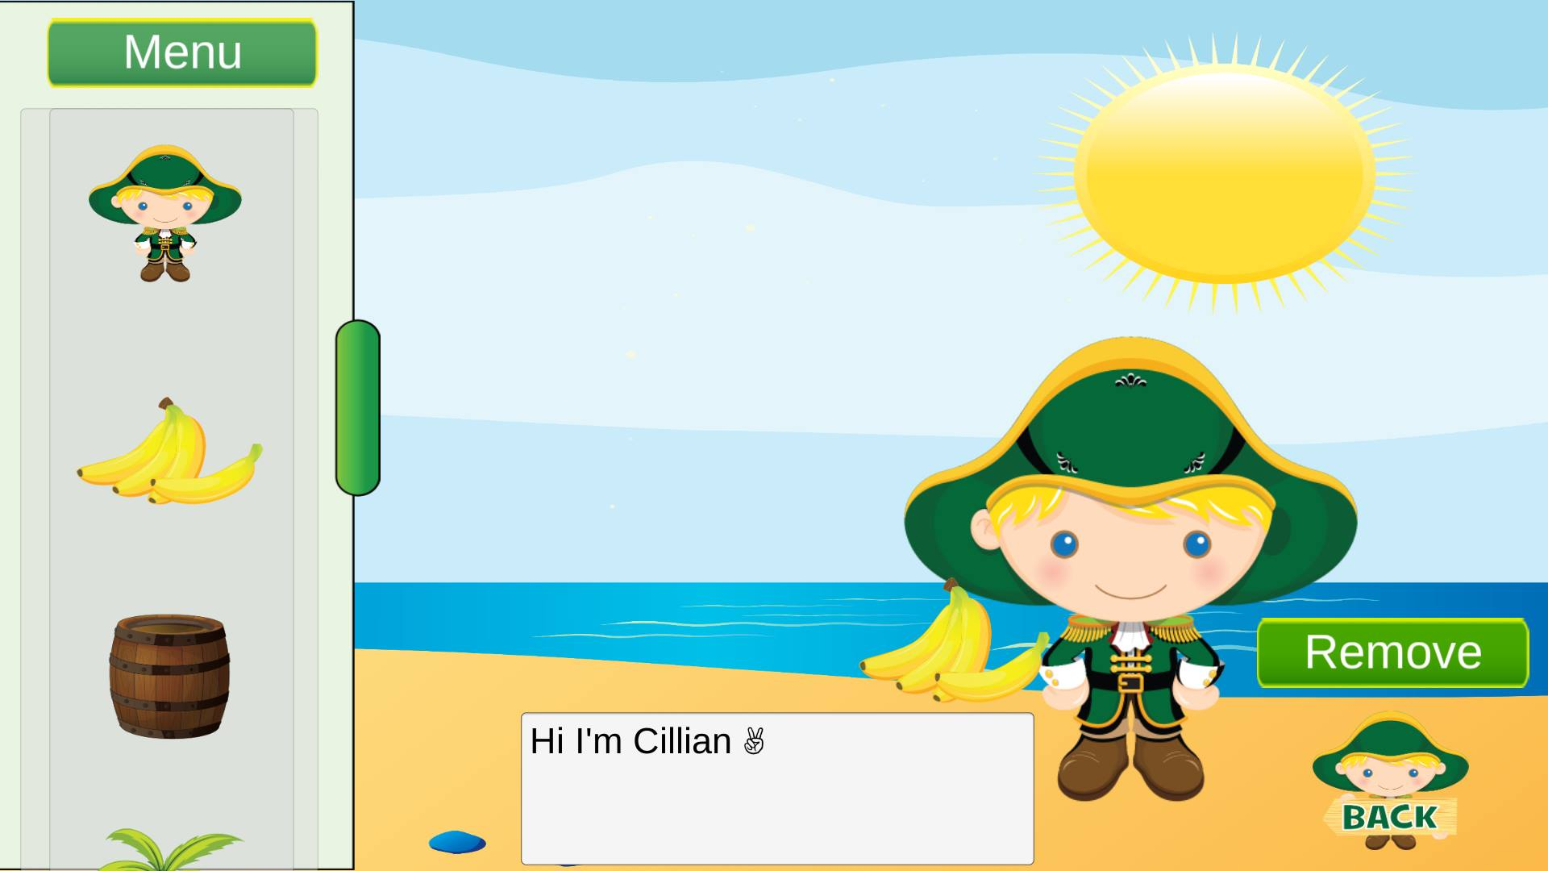

4.2 Ocean Facts

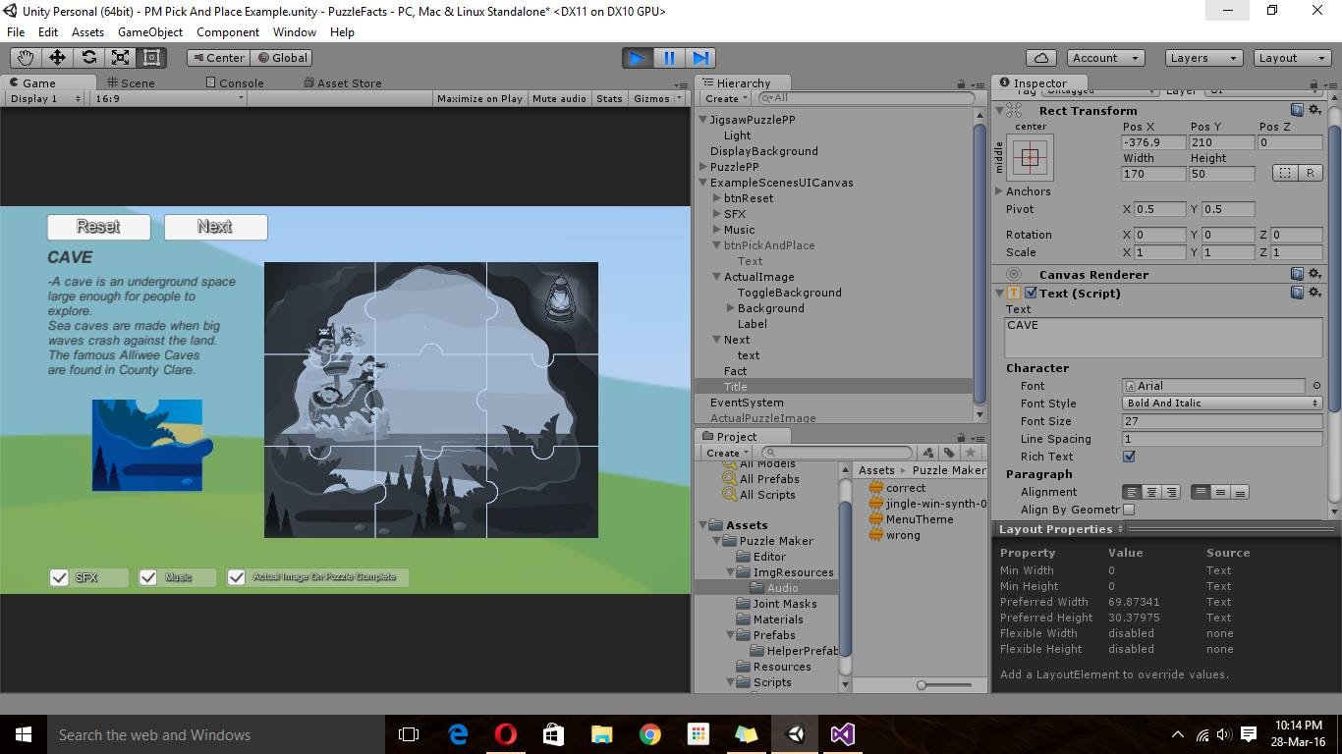

-This is the Pick and place puzzle game which displays one fact about one of the books.

- Smart approach in getting children to have fun and enjoy playing a game while also learning.

-This section implements sound .When the puzzle is completed.

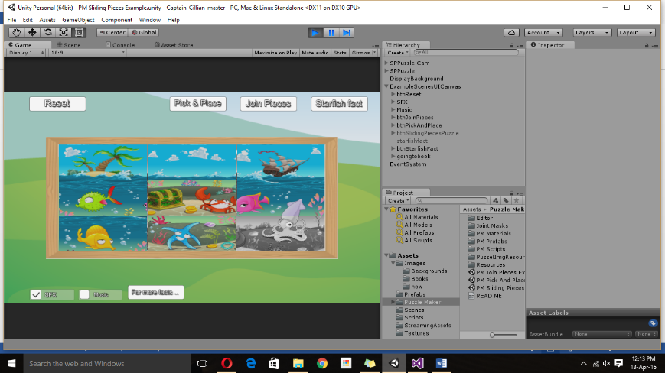-Added three different puzzles for each book.

-This is a sliding puzzle.

-At the bottom I decided to add a button that will bring you to one of the books.

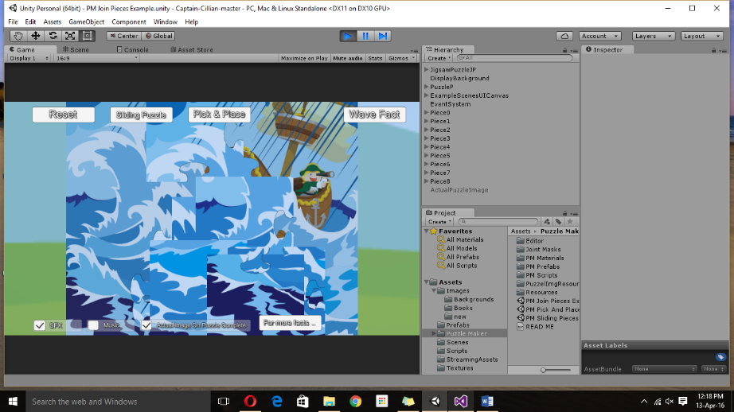-This is a Join the pieces puzzle.

-That also contains one fact about another book.

-Decided to add only one fact per book since the customer is using this as a promotion software.

- So in the button “For more fact…” customers will be brought to the website where they can buy the book to find out more facts.

4.3 Learn Irish

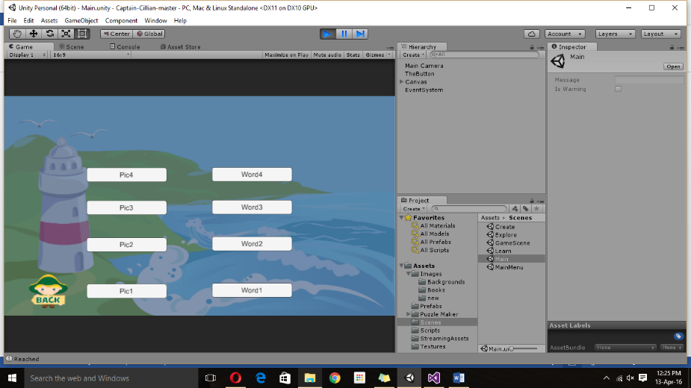

-In this section we added a match the word and picture game.

-After researching this we found that it would be the most effective way for children to visualize and also learn Irish words.

-It will be useful for using in the classrooms as our client is visualizing this to be used in schools.

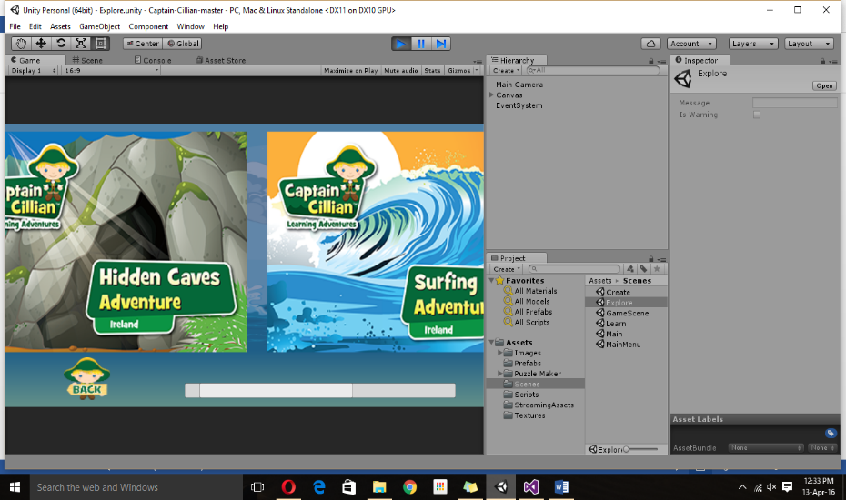4.4 Explore

-The explore section will only contain the selection of books that have been made.

-Each book will be linked to a website there the book can be bought.

-This is the best way we can promote the clients books and also the clients website

4.5 Database Stuff

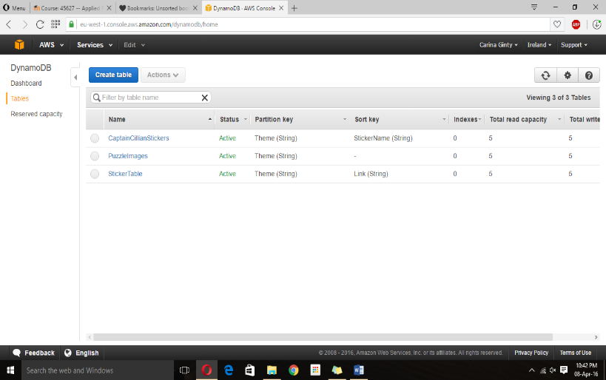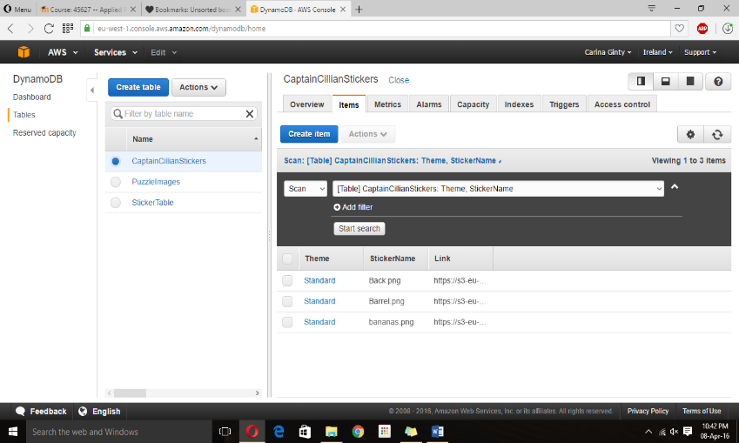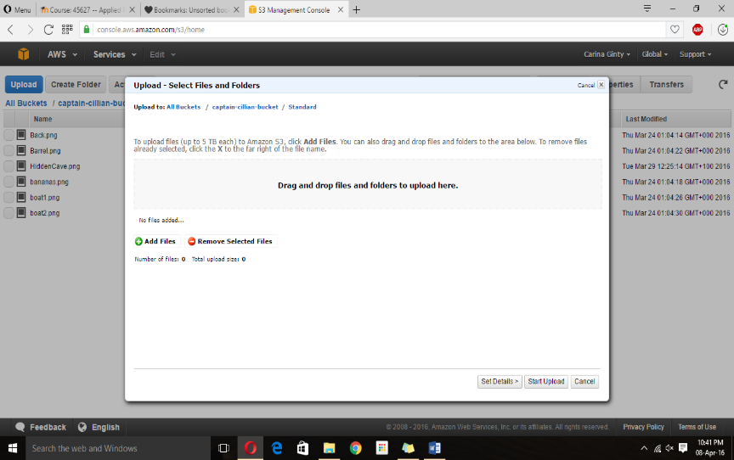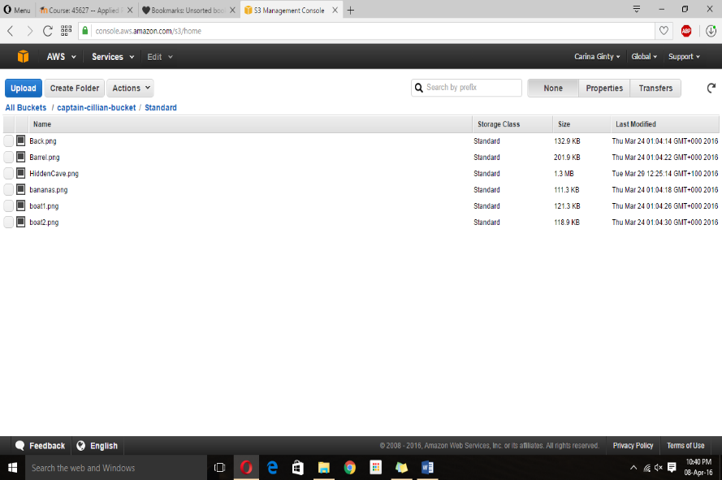The following screenshots show our database and how the database functions. We chose to use this particular database because it has a free trail for one year. Our client wasn’t sure she wanted to use a database to upload more information on this application. She initially wanted to create a new app for each batch of books she created. But since we had to add a level of complexity to our project we decided to give her this option. After the year passes she has the choice of continuing to use this or to leave it aside.